**KHAREED LO**

Group Members

1. Owais Sultan (18K-0303)
2. Abdul Basit Imam (18K-0274)
3. Mugheera Bin Sadiq (18K-0296)

**1-Introduction**

**Khareed LO** is an E-commerce grocery store that aims to take care of shopping needs in a **SMART** way; making life easier for all customers. The main scope of this application is to sell quality and fresh grocery products in a reasonable amount of money. E-commerce is making millions of revenue from the past two to three years. Your store can earn trust on large marketplaces with huge customer bases, but once you’ve grown to a certain stage. So, it is beneficial to invest money on e-commerce now a days.

The main scope of this application is to sell grocery products which are mentioned below.

* Vegetables
* Dried Fruits
* Fruits
* Juices

**2-Motivation**

* Ecommerce has been getting a lot of attention in the past few years, and has succeeded in making online trading a lot easier.
* Before E-commerce was introduced people had to buy their daily needs products by going to markets which was very hectic and wastes a lot of productive time.
* Due to comparatively low investment in ecommerce and stiff competition in online businesses, customers can get the best deal and more opportunities for bargaining.
* KHAREED LO customers can surf the various stores for a wide range of products to make a better choice.
* To overcome this problem many online Ecommerce softwares developed which eventually took trading to the next level.
* We have tried to make our software KHAREEDLO with the same E-commerce functionalities as famous Software FLIPKART.
* KHAREEDLO can be improved by making it more customized and adding more products to make it a fully functional running web Ecommerce store.

**3-Significance**

The main purpose of our E-commerce business store is to facilitate people in selling and purchasing items in a feasible way, We are looking forward to facilitating our customers in purchasing of their groceries i.e Fruits ,Vegetable , Dried and juices.The main scope of this application is to sell quality and fresh grocery products in a reasonable amount of money.

If you have ever been shopping around on an ecommerce website, you might know that online trading is in high demand; after all, it gives people an opportunity to buy their required stuff from the comfort of their home. So to give your customers a convincing buying experience and give them better support is the key for which every business should build an ecommerce website.

**4-Description**

KHAREEDLO is an online Ecommerce solution for trading and businesses. It is a similar kind of application like many famous applications i.e Daraz.pk, FlipKart etc.

**5-Main Features**

* Account management
* Cart
* Offers
* Discounts
* Admin Panel
* Freshness level (if the product is not fresh then a decent amount of discount will be given on that particular product)

**6-Hardware and Software requirements**

**Hardware Requirements:**

Hardware requirements for high-traffic sites may be dependent on

the following issues: number of transactions per second, number of hits per second, number of queries per second, number of queries done by RDBMS per second, number of pages served per second involving all of the above parameters.

So to control all these constraints we need a strong server which can respond to multiple requests at the same time, backup servers if the server fails.

**Software Requirements:**

Front-end

* React
* Bootstrap
* CSS3
* HTML
* JavaScript

Back-end

* NodeJS
* ExpressJS
* MongoDB

**Continued to next page**

**7- ERD and Front End Screens**

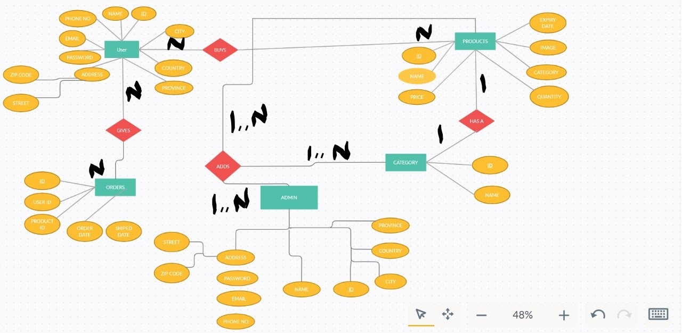

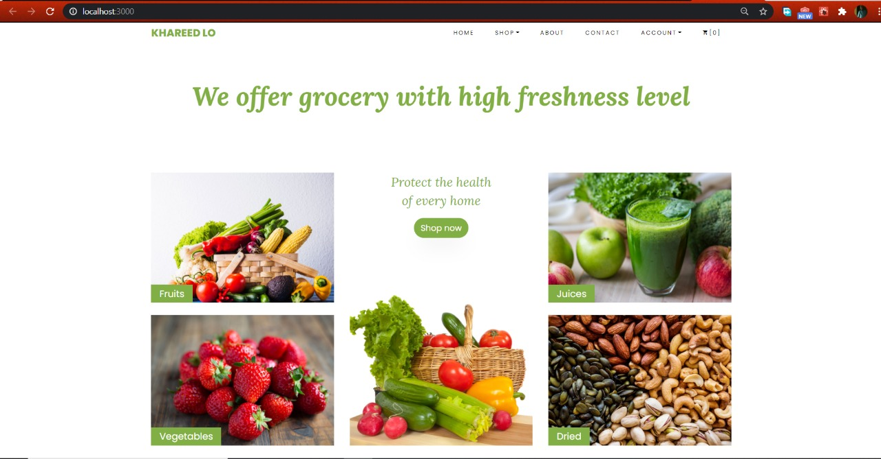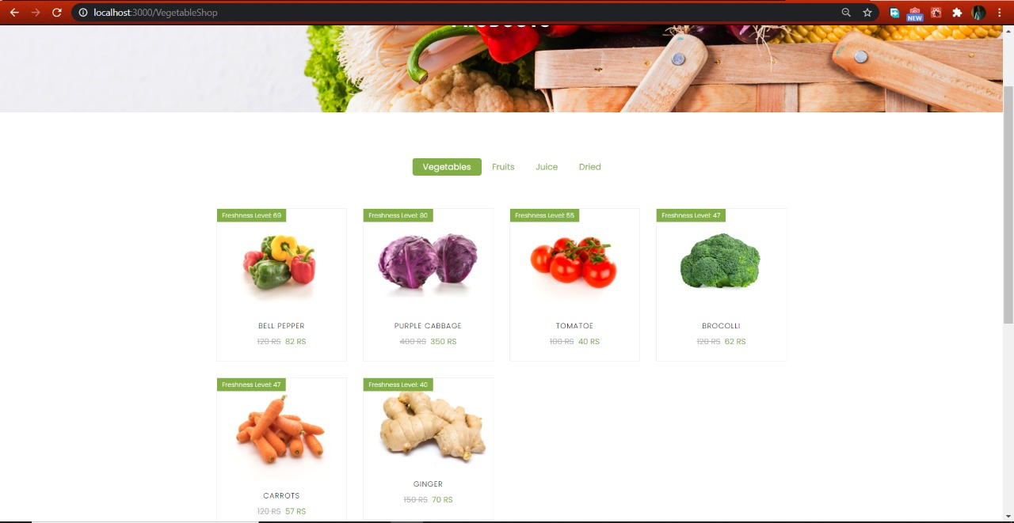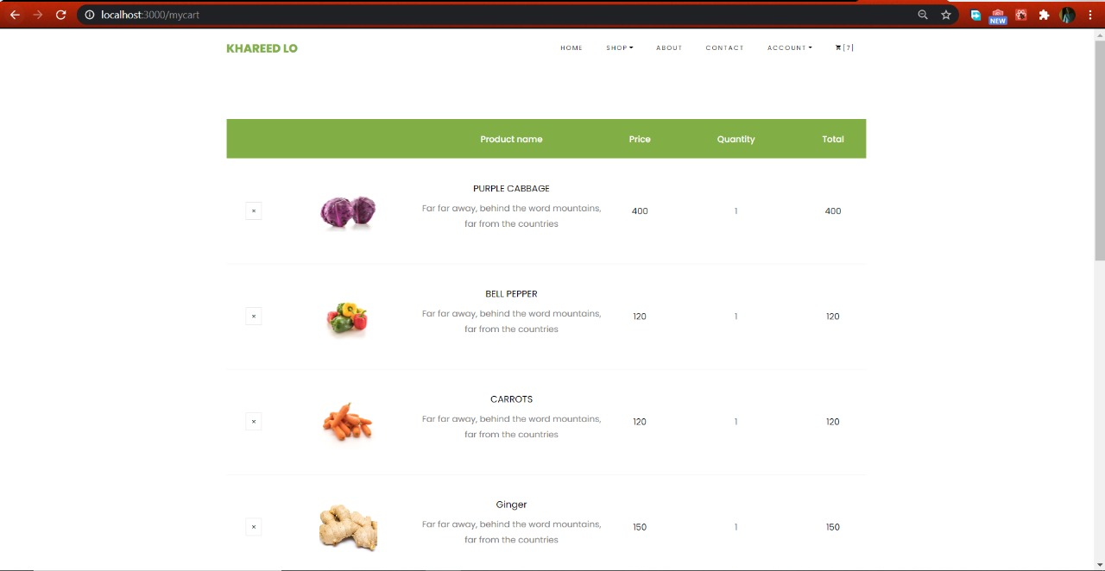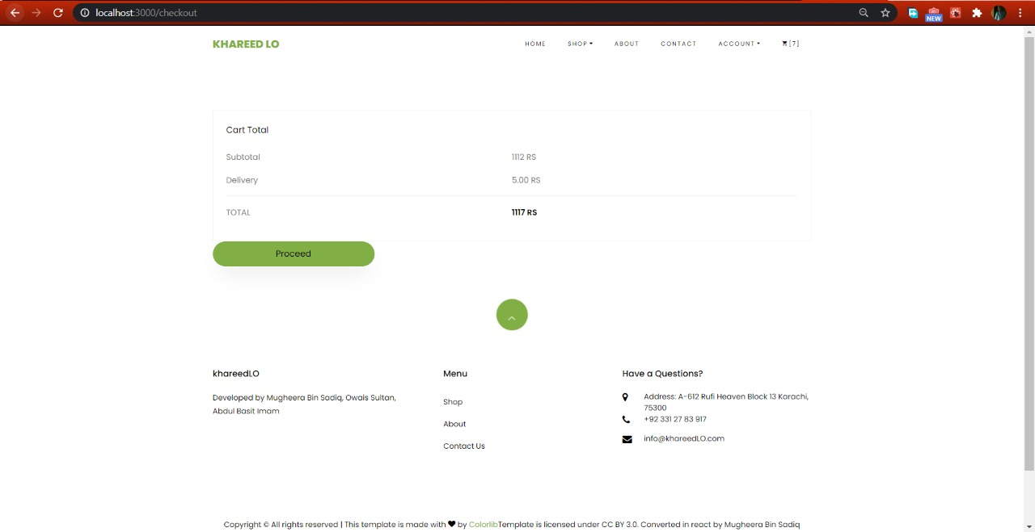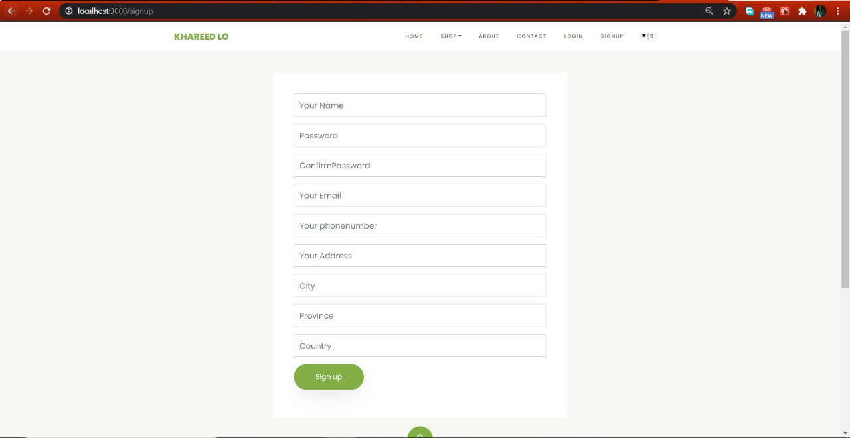

**ADMIN PANEL:**

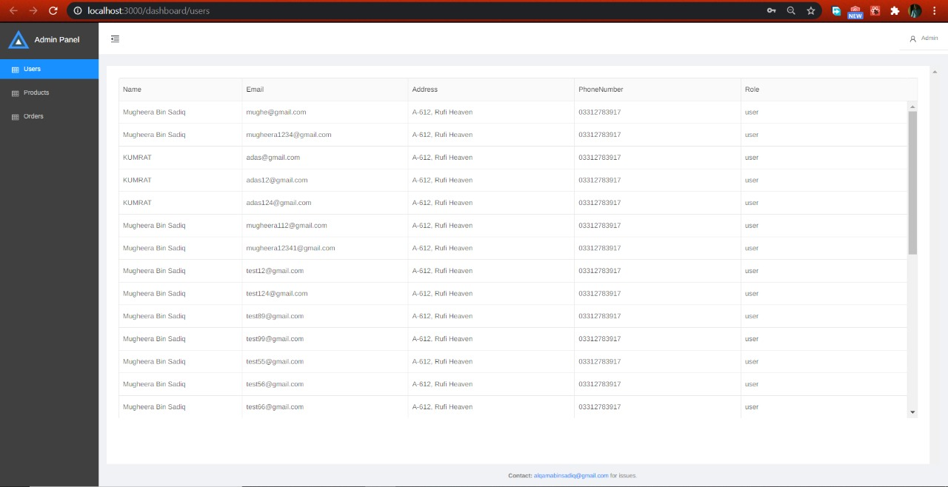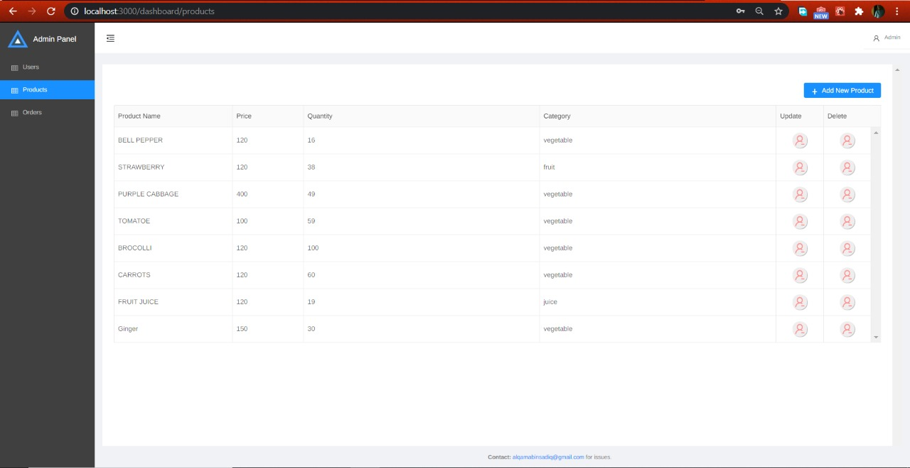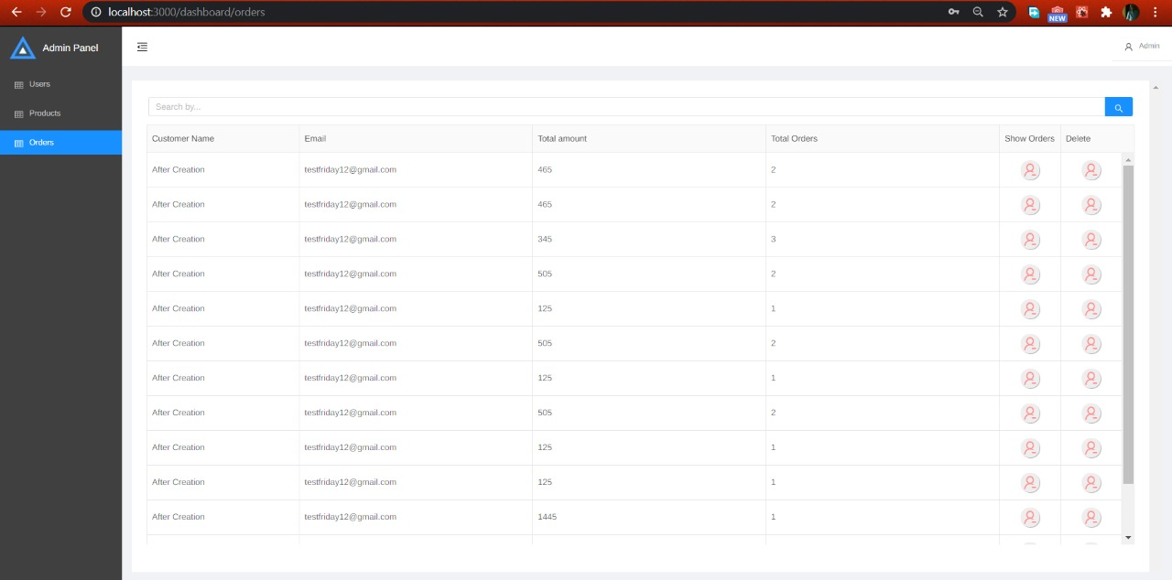

**­­­8-References**

* [**https://docs.mongodb.com/manual/**](https://docs.mongodb.com/manual/)
* [**https://reactjs.org/docs/getting-started.html**](https://reactjs.org/docs/getting-started.html)
* [**https://nodejs.org/en/docs/**](https://nodejs.org/en/docs/)
* [**https://stackoverflow.com/questions/2353818/how-do-i-get-started-with-node-js**](https://stackoverflow.com/questions/2353818/how-do-i-get-started-with-node-js)
* [**https://stackoverflow.com/questions/tagged/mongodb**](https://stackoverflow.com/questions/tagged/mongodb)